Help with breastfeeding for Merton mothers
You are not alone. There is support and help available to all mothers who breastfeed ranging from professional advice, peer-support, helplines, websites and apps. This leaflet provides information about the services available in Merton.
Group and one-to-one support
Professional advice and support from breastfeeding councillors is available to help you with breastfeeding.
Name and venue | Day and time | Booking information
Breastfeeding drop-in (run by Merton Health Visiting)  Church Road Children’s Centre, 243 Church Rd, CR4 3LS | Wednesdays  13:00 – 14:30 | Drop-in  First come first serve  Free service
Tweeddale Children’s Centre Breastfeeding Clinic (run by St Helier Midwifery Service)  Tweedale Children’s Centre, Tweedale Road, Carshalton, Surrey, SM5 1SW | Thursdays  10:00 – 12:00 | Drop-in  First come first serve  Free service  To check times call: 07975 232 374
Café La Leche Merton in Wimbledon  Hill side Church, 37 Worple Road, SW19 4JZ | Tuesdays  10:00 – 12:00  (two session per month) | Drop-in  First come first serve  Free service  Please check website for updates
NCT Wimbledon Breastfeeding Drop In  Gooseberry Bush Café, 115 Kingston Road, SW19 1LT | Thursdays  10:00 – 12:00  (last entrance 11:30) | Drop-in  First come first serve  Free service
Kingston Hospital Infant Feeding Team  Galsworthy Road, Kingston upon Thames, Surrey, KT2 7QB | - | By appointment at; call 07595 091 974 for a telephone consultation  Free service  For babies born at Kingston Hospital; seen up to 28 days after birth
Breastfeeding London Clinic  SW19 3DS | Tuesdays  9:00 – 12:00 | By appointment only; call 07414 490 090 to book  Free service

Helplines
When you can’t see someone face-to-face, support is just a phone call away.
Merton Health Visiting Service  HELPLINE: 03300 539 264  3:00 pm – 5:00 pm Mon – Fri | National Breastfeeding Helpline  HELPLINE: 0300 100 0212  9:30am to 9:30 pm Mon – Sun  http://www.nationalbreastfeedinghelpline.org.uk  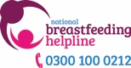
Breastfeeding Network (BFN)  HELPLINE: 0300 1000 210  9:30am to 9:30 pm Mon – Sun  http://www.breastfeedingnetwork.org.uk | La Leche League  HELPLINES: 0345 120 2918 / 0845 120 2918  http://www.laleche.org.uk  Mother–to–mother support
Association of Breastfeeding Mothers (ABM)  HELPLINES: 08444 122 949 /0300 330 5453  9.30am - 10.30pm Mon – Sun  http://www.abm.me.uk  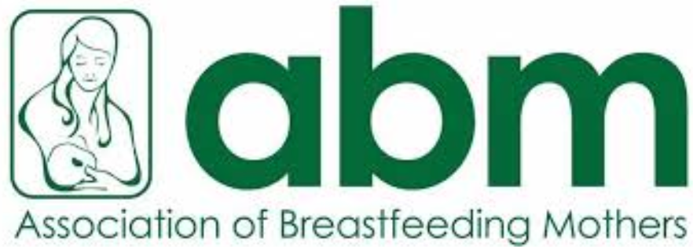 | National Childbirth Trust (NCT)  HELPLINE: 0300 330 0771  8am – midnight Mon – Sun  www.nct.org.uk

Useful websites
First Steps Nutrition Trust: Independent public health nutrition charity. Evidence based resources include information on infant milks, commercial baby foods and healthy eating.  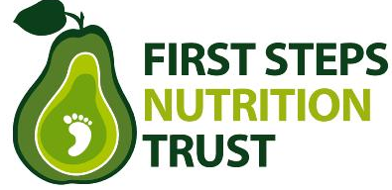 | UNICEF Baby Friendly Initiative: Excellent breastfeeding videos, information and resources for parents.  https://www.unicef.org.uk/babyfriendly
Global Health Media:  Videos to help with positioning, attachment and other common breastfeeding queries.  https://globalhealthmedia.org/videos/ | Baby Sleep:  Research evidence about biologically normal sleep for human babies. App available.  https://sites.durham.ac.uk/basis
Breastfeeding Network drugs in breastmilk information:
druginformation@breastfeedingnetwork.org.uk or
Facebook Page The breastfeeding Network Drugs in Breastmilk information service

Apps
Baby Buddy app:  www.bestbeginnings.org.uk/babybuddy | NHS Breast Start app:  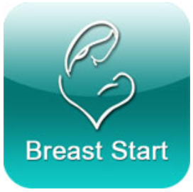

Last updated: February 2019
Review: July 2019

